***SPYDER BOT***

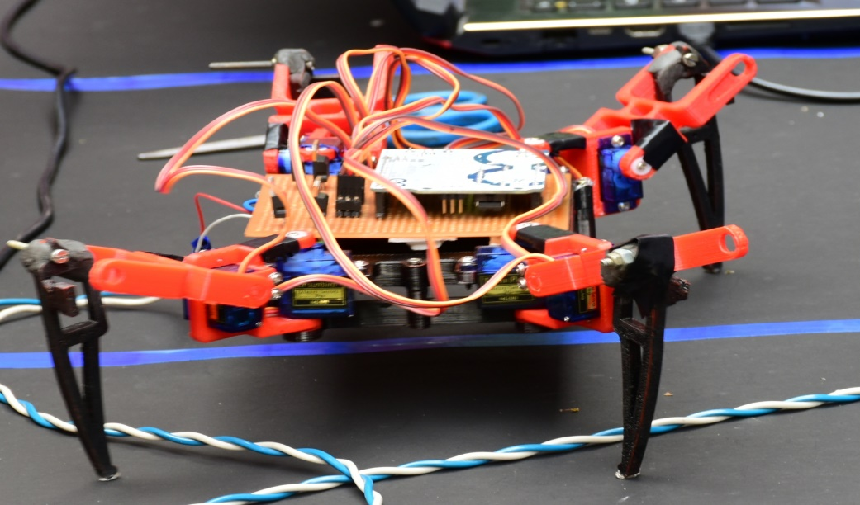

***INTRODUCTION:-***

* A **quadruped bot** capable of walking in all terrain,even discontinuous paths with ease,actuated with help of 8 servo motors.As its name suggest ,quadruped robots have four legs and follow the gait patterns of quadruped animals.They are more stable than biped robots.The 8 SERVO MOTORS of quadruped bot helps it in many movements and activities which are not possible for wheeled robots .

***GAIT ANALYSIS:-***

* **A** manner of walking or moving on foot is known as gait.
* Generally used gait for quadruped(four legged) bot:-1.CREEP GAIT

2.TROT GAIT.

***GAIT USED IN THIS ROBOT:-***

* **CREEP GAIT** was used in this quadruped bot.

The creep gait is the easiest walking gait to use. The robot keeps three feet on the ground, and keeps its center of gravity (CoG) inside the triangle formed by those three feet. If the CoG goes outside this triangle for too long, it will fall over.

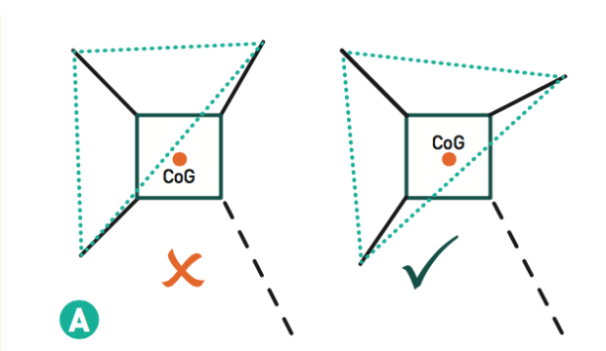

**Fig-2.**

This figure shows that it is necessary to have COG placed inside the triangle formed by the three legs of the bot if fourth leg is not in contact with the ground.

If COG will not be placed inside the triangle then bot will fall if any external force will be applied at the edges.

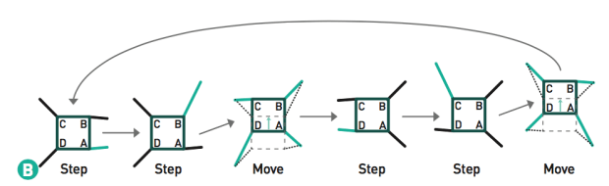

**Fig_3**

This figure shows the forward movement of four legs of our robot using creep gait.

***COMPONENTS USED:-***

* 8 servo sg-90 motors.
* 1 arduino UNO
* 3d printed parts(for body)
* 12v dc adapter
* Voltage regulators(LM7806 &LM7809) to step down voltage from 12 v to 6v.
* Perforated board.
* 3mm nuts and bolts.

***3d parts stl files :-***

Link for the drive:-

https://drive.google.com/open?id=1sPnbQW4tyhGKC7R8eUUncGz6zT5Wx7Nr

***ARDUINO CODE USED :-***

Link for the drive:-

https://drive.google.com/file/d/1oX-LWr5rQLgQnREmbut73sfBRDB2y3J8/view?usp=sharing

***PROBLEM FACED:-***

* Connecting tibia to femur.

Solution-can be connected using nut and bolt and can be fixed using m-seal.

* Problem was faced during connecting servo and other component to the breadboard.

Solution-prefer perforated board and solder all the wires according to circuit.

* Overheating of voltage regulators.

Solution-use heat sink for voltage regulators.

A PROJECT BY **:-**

**Rishav Raj(EEE K18)**

**Madhwesh Anand (IT K18)**